The Phi Beta Upsilon Newsletter

Fall 2010

Phi Beta Golf 2010 – Derryfield Country Club

[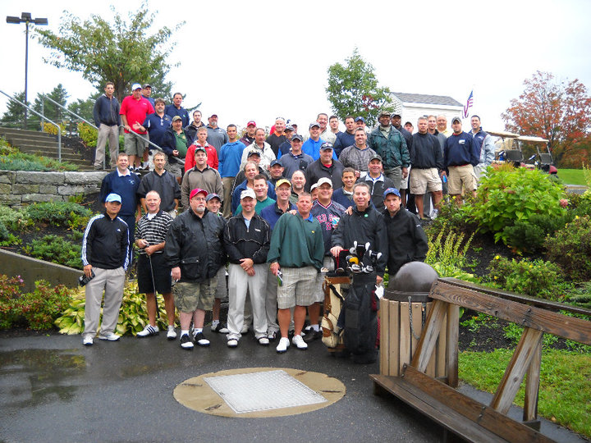](http://www.facebook.com/photo.php?pid=5166152&id=582722544)

**Newsletter Mission Statement**

*Provide news and information to the brothers of Phi Beta Upsilon.*

*Serve as a communication link to bring brothers together; alumni and*

*active brothers at PSU. Promote a spirit of fraternity, brotherhood & unity*

2010 Stanimal Open at Derryfield Country Club, Manchester NH on September 17th

Pictured above- Brothers and friends who participated in the 2010 Stanimal Open

***The annual Fall Golf Tournament and Homecoming Weekend highlight recent Phi Beta Upsilon activity.***

**Fall 2010 Golf Tournament:** (Derryfield Country Club) This year’s Golf Tournament was a huge success which set record attendance and money raised. A rainy morning transitioned into a nice crisp day of golf and a meeting of friends. A big thank you to Kendal Turner for taking the helm for this excellent event.



Players: 62

Total Revenue Raised: $8,500

Gross Profit: $3,739

Placing information is as follows:

**1st Place:** Team of Rodney and Randy McQuate, Craig Buttersby, and Greg Bolton. Won with a total of 62.

**2nd Place:** Team of Terry Fife, Phil Converse, “The Captain”, and Ross Oberg with a score of 63.

**3rd Place:** Jeff White, Peter Halloran, Joey Bourgeis, and Paul Sevigny with a score of 64.

**Longest Drive**: Greg Zerega

**Schlitz Prize for Worst Score:** Pete Lyons, Jay Doucette and Gary Collins

Hello Brothers;  
   
As you know Phi Beta Upsilon has invested in the construction of a Veterans Memorial Park located in the area of the old Lambda Chi fraternity.  Since the construction, this park has been used by the University to conduct their Veterans Day celebrations.  This year is no different except for the fact that the keynote speaker is a Phi Beta Upsilon Alumni Brother.     
   
**Bruce Wiggett Sr.**, a retired president and CEO of Vermont Yankee Nuclear Power Corporation and resident of Plymouth, NH.  He has worked tirelessly on behalf of Brattleboro Memorial Hospital in Brattleboro, VT and other worthy non-profits across New England, and is a **Alumni Brother of Phi Beta Upsilon** who pledged in 1972.  He is currently a Professor in the Business Dept of Plymouth State University, and the President of the Plymouth State University Alumni Board among other notable allocates.  
   
Bruce will be representing not just the University, but the Brothers of Phi Beta Upsilon when he speaks at this year’s Veterans celebrations.  I would like to invite any Brother or Alumni Brother of Phi Beta Upsilon to attend this year’s Veterans celebration to support Bruce in honoring our Veterans on Thursday November 11th 2010.    
   
We are also working on having the prayer at the opening or closing of the event said by another Phi Beta Alumni.  Upon approval of the University we will seek out Pastor David Richardson of the Hooksett Congregational Church, or Father Craig Cheeney of the St. Brendan's church in Colebrook NH.  Both are Alumni Brothers of Phi Beta Upsilon who pledged in the 70's  
   
In closing the Board Members of 27 Highland Ave. would like to thank all the alumni who have attended and participated in any of this year’s fund raisers, or financially supported the philanthropy of the Phi Beta Upsilon Alumni Association.  We could not do this without **YOU!!!**  
   
   
Thank You**,**  
   
**Terrence R. McKenzie** 'Spring 1982'  
President   
Phi Beta Upsilon alumni Association

**FRATERNITY BROTHERHOOD UNITY**

**Homecoming Weekend:** This year’s homecoming weekend saw a great turnout and an increasingly positive relationship between Beta alumni and actives. Alumni were welcomed to the new active house on Thurlow St where brothers of Phi Beta Upsilon new and old were able to rub elbows and trade stories. Surviving Sororities and their alumni also helped to make the weekend enjoyable. Conversation was not limited to taking place at Plymouth State bars.

**Distinguished Alumni Award:** One of the main events of this year’s Homecoming was the Plymouth State University 2010 Alumni Recognition Awards. It was here that 27 Highland Ave paid off the remaining debt to PSU for the Veteran’s Common located in front of Hyde Hall. At this year’s ceremony, we saw Steve King (class of ’86) receive the Distinguished Alumni Service Award. King received this award for the leadership he demonstrated in forming 27 Highland Ave – the Phi Beta Upsilon alumni organization. Through countless hours of his own time, King outreached to Beta Alumni, soliciting cooperation to get the organization formed and into a productive entity. If organizing alumni was not a hard enough task, King also was successful in getting Plymouth State University to listen to, and eventually recognize 27 Highland Ave as a viable alumni organization. Once the organization was on solid footing, King then arranged for the Veteran’s Common to be built on a central location outside of Hyde Hall, reminding the campus of Phi Beta Upsilon’s original mission of commitment to veterans past and present, and continuing community support. In a proud moment that was a true milestone for how far the organization has gone in its first three years, King accepted the award on behalf of 27 Highland Ave and all Brothers who have worked for its cause.

[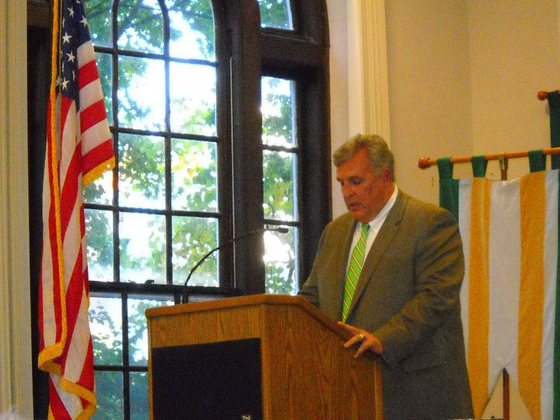](http://www.facebook.com/photo.php?pid=5260581&id=582722544)

Steve King accepts the 2010 Distinguished Alumni Service Award at Plymouth State University

**Merit Award Presentation:** On Wednesday, September 29th, President Terry McKenzie accompanied by Scott Turner, George Pervanas, Andrew McDonnell, and Jeff Leclerc, traveled to Plymouth to present the 2010 Merit Award to this semester’s winner: Kyle Danie. Kyle was voted by the board to receive the Fall merit award based on his GPA and community service involvement. The merit award check of $500 was presented at the last Fall rush, so that actives and rushes alike could witness the seriousness of 27 Highland Ave’s commitment to active academics and community involvement.

[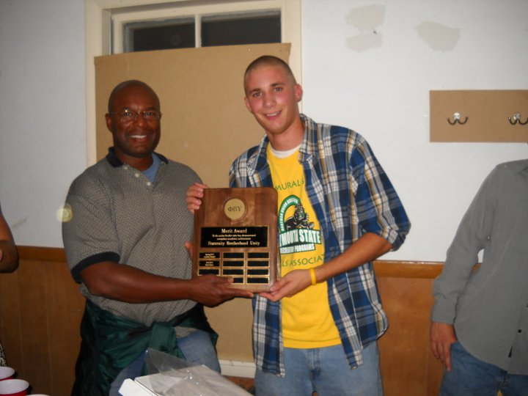](http://www.facebook.com/photo.php?pid=5527324&id=299986061984)

27 Highland Ave PresidentTerrie McKenzie presents Merit Award to Phi Beta Upsilon active Kyle Danie

**Position Changes:** For those who don’t know, Terry McKenzie is now the new President of 27 Highland Ave. Terry will be taking the place of Steve King, who is stepping down after heading the organization for three successful years. Thank you Steve for your hard work and vision which got us to the place we are now.

Vice President: Terry Fife

Treasurer: Tony Albright

Secretary: Jeff Leclerc

Elected to the board: Andrew McDonnell, Pete Lyons, Jeff Leclerc, and Terry McKenzie

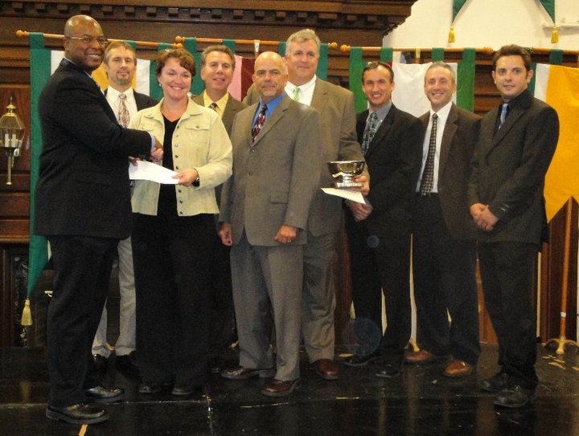

27 Highland pays off remaining debt for Veteran’s Common at PSU Alumni Award ceremony. Pictured left to right: Terry McKenzie, Tony Albright, George Pervanas, Terry Fife, Stephen King, Scott Turner, Dana Gaudette, Jeff Leclerc

**Board Meeting Update:**  The Board of Directors met on August 7th in Nashua, NH- agenda items were:

* Upcoming Turkey Drive
* 4oth Anniversary plans
* Future of the organization
* Golf results

**Thanksgiving 2010 Turkey Food Drive**: 27 Highland Ave will be engaging in a Turkey Food Drive for needy families in the Plymouth, NH area for its next philanthropic project. Plans are in the works to team up with the Campus Ministry Office to form a large scale charitable effort for families hit hard by the recent economy. On the 22nd or 23rd of November, we will be working with Active Phi Beta Upsilon members to deliver food baskets around the community.

At this time, the Board would like to announce that Steve “Smokey” Robinson challenges all business owners to match his contribution of $300 to this cause. Jeff White has already answered with a pledge of $250. Combined with 27 Highland Ave’s commitment of $1,500, this funds this effort with around $2,000. Let’s show the school and community how serious we are in our mission for community betterment. Please make your contribution by October 25th 2010 as the food will need to be ordered at this date.

You can make contributions online at [27 Highland Ave Paypal](https://www.paypal.com/us/cgi-bin/webscr?cmd=_flow&SESSION=iw_8orKNQQ1l8ajsXI3B2jikqzs6c946uNL-Rui_cxI-p038wnSs7wi_IGC&dispatch=5885d80a13c0db1f8e263663d3faee8dc60d77e6184470d51976060a4ab6ee74). You can also write checks. If doing so, please send to:

Tony Albright

Brayman, Houle, Keating & Albright, PLLC

12 Cotton Road,

Nashua, NH 03063

**Make check payable to : 27 Highland Avenue Association**

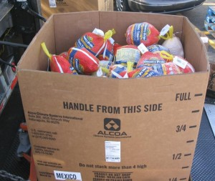

***PAYPAL IS HERE!!!***

Brothers now have the ease of paying dues, making donations, and event payments via PayPal. Go to [www.27highland.org](http://www.27highland.org) for info

***What do you want to do for the 40th Anniversary?***

The idea of celebrating the fraternity’s 40th year anniversary at Indian Head Resort in Lincoln, NH has been tossed around. The current plan is for a one night extravaganza, but input and suggestions of other places are greatly encouraged. You can check out the resort at the following page: <http://www.indianheadresort.com/>.

Another idea that has been brought up is to have the festivities take place at Plymouth instead.

Please e-mail Jeff at [phibetaupsilon@gmail.com](mailto:phibetaupsilon@gmail.com) with your input and ideas for the 40th Anniversary

**UPCOMING EVENTS!!!!**

**HOLD THE DATE**

**Turkey Drive Contribution Deadline**

**October 25th, 2010**

[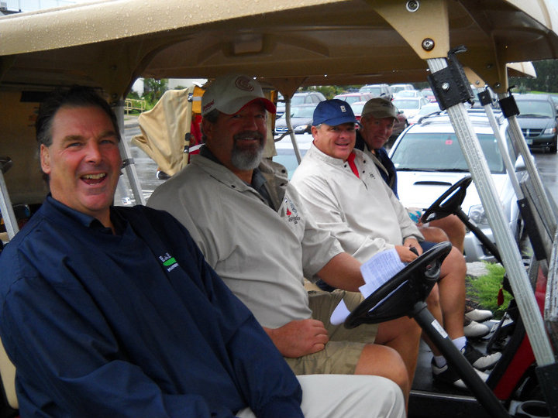](http://www.facebook.com/photo.php?pid=5166211&id=582722544)

Gentlemen, start your engines.

**_____________________**

Pictures from 2010 Stanimal Open

[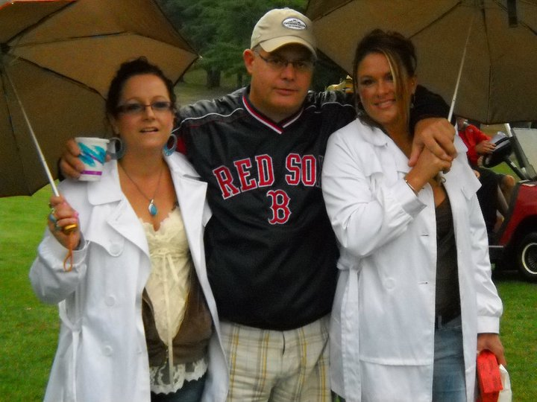](http://www.facebook.com/photo.php?pid=5260756&id=582722544)

Kendal Turner is the pimp

[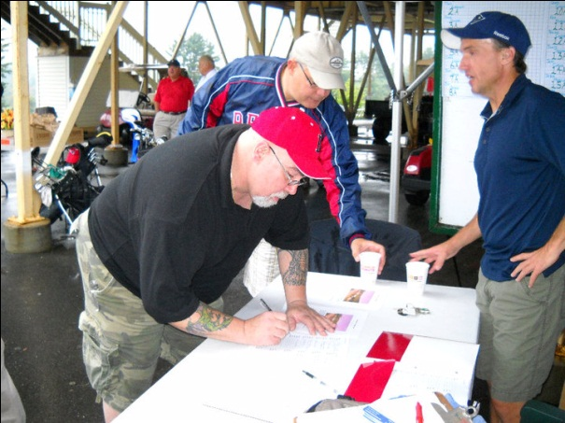](http://www.facebook.com/photo.php?pid=5166150&id=582722544)

Signing autographs

Jay Doucett, Kendall Turner, Scott Turner

[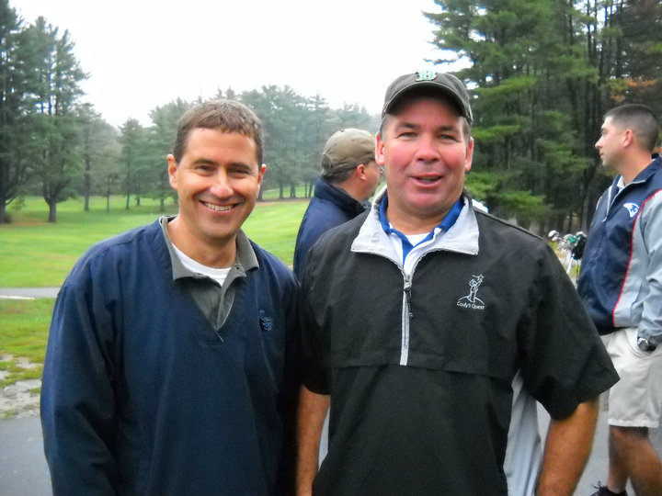](http://www.facebook.com/photo.php?pid=5166151&id=582722544)

We drank the rain clouds away

[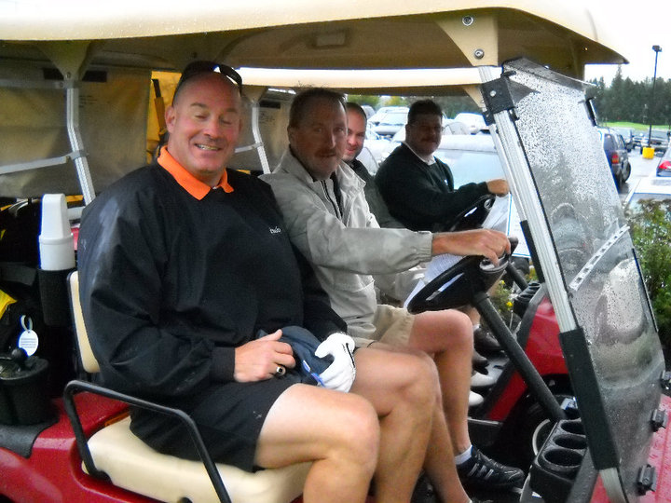](http://www.facebook.com/photo.php?pid=5166209&id=582722544)

At least you ain’t driving

[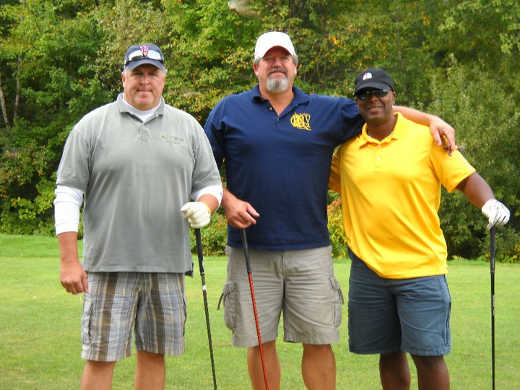](http://www.facebook.com/photo.php?pid=5166149&id=582722544)

**PIICTURES WANTED** – Please send along any IBY pictures you may have for future Newsletters.

Send to: [PhiBetaUpsilon@gmail.com](mailto:PhiBetaUpsilon@gmail.com)

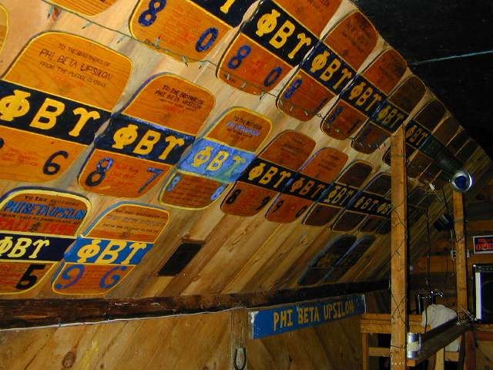

[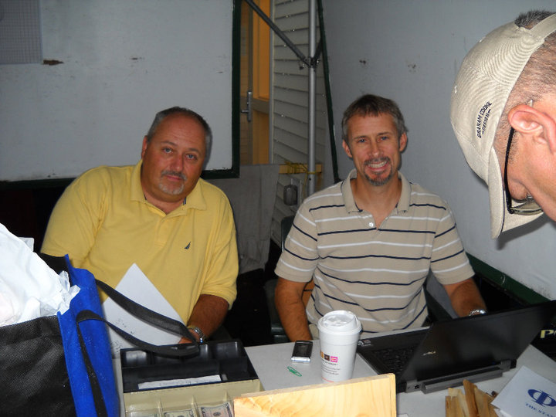](http://www.facebook.com/photo.php?pid=5166153&id=582722544)

pictured: Pete Lyons and Tony Alright

We invested all golf money into Lehman Brothers

**Supporta Brotha**

**In this section we post the businesses of our Brothers. Contacts have been divided into business category. To request a posting, please e-mail** [phibetaupsilon@gmail.com](mailto:phibetaupsilon@gmail.com)

# Accountant

**Anthony W. Albright, CPA∙ABV**

Brayman, Houle, Keating & Albright pllc

12 Cotton Road

Nashua, NH 03063

***603-595-8000***

603-595-8039 (fax)

# Auto Sales

**Dan Reitz**

**BONNERVILLE & SON**

**CHRYSLER * JEEP * DODGE * KIA**

**(603) 624-9280 EXT. 557**

(800) 640-9280

Cell (603) 998-9109

Fax (603) 644-3665

[www.bonnevilleandson.com](http://www.bonnevilleandson.com)

# Auto*Home* Life* Accident Insurance

# Kendall J. Turner, MBA

# *Insurance Professional* 1065 Hanover St Manchester, NH 03104 *Office: 627-4788 ext 12* Fax: 627-6368

[TURNERK1@nationwide.com](mailto:TURNERK1@nationwide.com)

**Comprehensive Business Insurance, Employee Benefits, and Employer Sponsored Retirement Planning**

**Jeffrey P White, CLU ChFC**

Harbor Insurance Group, LLC

Investors Capital Corporation

Cornerstone Building

Suite 203A South

Rockland, Mass 02370

781-792-0990

jeffw@harborinsgroup.com

jwhite@investorscapital.com

# Construction

# Supplies/Sales

**Jeffrey Guimont**

***Associated Concrete Coatings Inc***

476 Valley St

Manchester, NH 03103

***(603) 669-2780***

**Craig Howland**

***Howland Insulation and Home Improvement***

45 Chapin Terrace  
Laconia, NH 03246-2307

***(603) 524-2009‎***

**Kyle Niemla**

***Builders Insulation Co Inc***

62 King St.

Auburn, NH 03032

***(603) 668-4411***

**Scott Slade**

***Benson Lumber & Hardware***  
6 Martin St  
Derry, NH 03038-2311  
***Phone: (603) 432-2531***  
Fax: (603) 432-2018

# Justice of the Peace

**Terrence R. McKenzie**

125 Lindsey Way

Goffstown, NH 03045

**(603) 361-2220**

[mpd49nh@hotmail.com](mailto:mpd49nh@hotmail.com)

# Mortgages

**Brent Onufrak**

***Mortgage Masters Inc.***  
Bellingham, MA

|  |  |
| --- | --- |
| Description: Brent Onufrak | Walpole Massachusetts Office  Corporate Headquarters  102 Elm Street, 3rd floor  Walpole, MA 02081  Phone: 508.259.3924  Fax: 508.355.0349  [bonufrak@mortgagemasterinc.com](mailto:bonufrak@mortgagemasterinc.com) |

# Pastoral Services

**Pastor - David A. Richardson**

5 Veterans Dr.

Hooksett, New Hampshire 03106

United Church of Christ

***(603) 485-9009***

[www.hooksettucc.com](http://www.hooksettucc.com)

**Printer Supplies**

**Keith Murray**

Remanufactured Toner Supplier

Ink Cartridge Refilling and discount compatible cartridges on site

65 South Main St. Concord, NH 03301

603-856-7708 Office

603-321-5765 Direct/ Cell

603-286-2292 Fax

Web: www.InkSpotConcord.comEmail: Keith@InkSpotConcord.com

# Realtor

**George Pervanas**

***REALTOR®***

CRS-Certified Relocation Specialist

Coldwell Banker Residential Brokerage Amherst/ Bedford

103 Ponemah Rd. Amherst ,NH 03031

**603-673-4000 ext. 246**  Office

603-620-2249 Direct/ Cell

603-673-5330 Fax

[www.george.pervanas@nemoves.com](http://www.george.pervanas@nemoves.com)

**Bart Marchioni,**

**Real Estate Consultant** CA DRE# 01385188

Certified Foreclosure and Short Sale Specialist (CPFS, CSSS)

Keller Williams Realty – Silicon Valley

2110 S. Bascom Ave #101, Campbell, CA 95008

(408) 266-3100 x1 Office

www.MOREConsultants.com

Bart@MOREConsultants.com

# Skin, Nails, Cosmetics and Spa

**Alyssa A. McKenzie LLC.**

Marielle Salon  
150 Beech Street  
Manchester, NH

***(603) 361-2221***

[www.alyssamckenzie.com](http://www.alyssamckenzie.com)

# WE NEED YOUR HELP



We continue to have a need for volunteers who would be willing to serve as Pledge Class Representatives. We need 1 (one) Rep for the following:

1970-75

1976-80

1981-85

1986-90

1991-1995

1996-2000

2001-2005

2006-2008

Duties:

Help us update and keep our contact files current-- serve as the primary “go to” person for that class. Including, getting the word out on events and being an evangelist to help maximize participation.

*Please keep in mind that you must be fully dedicated to reaching out to brothers and responsible for reporting back with status updates to Board of Directors.*

If you are interested, contact one of the editors-

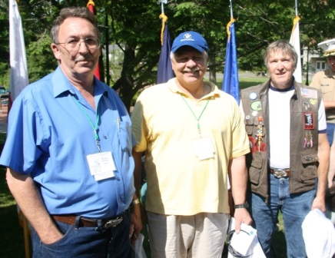

*From left to right Plymouth State alumni and Vietnam veterans Phillip Meader ’79, Rick Fournier ’77, and Lindsey Hartshorn ‘75 attended the dedication ceremony of the Veterans Common at Plymouth State University Saturday, June 27.*

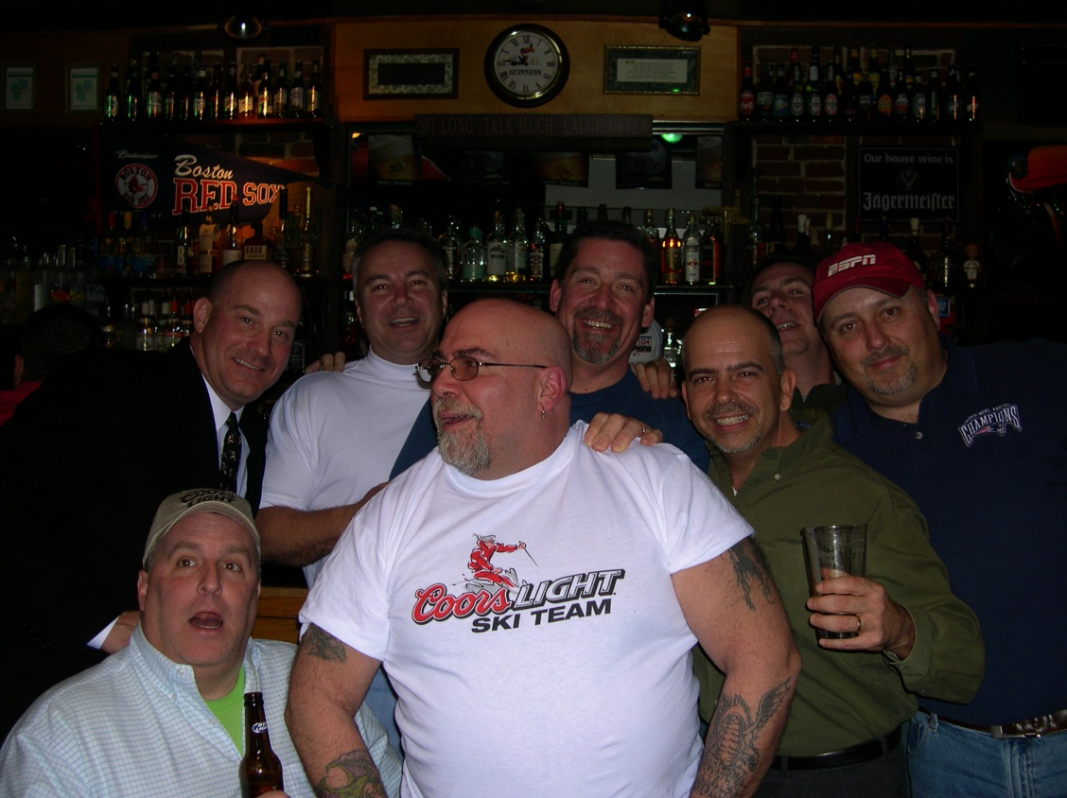

**Look for the next issue in the Winter!!!**

***Phi Beta Upsilon Newsletter –Fall 2010*Volume 3, 1st edition**Published Seasonally for:  
Phi Beta Upsilon Fraternity &   
Phi Beta Upsilon Alumni Association   
Plymouth State University,   
Plymouth, New Hampshire

Subscriptions are free to Brothers and Alumni of the Fraternity.

**Editors:**  
Jeff Leclerc (Fall ’04) – PhiBetaUpsilon@gmail.com

*This Month Cover: Best Golf Turnout Yet- October 8th, 2010*